SERVICE STRATEGY REFRESH EXECUTION HANDBOOK VERSION NOV 2015（万枫中国）

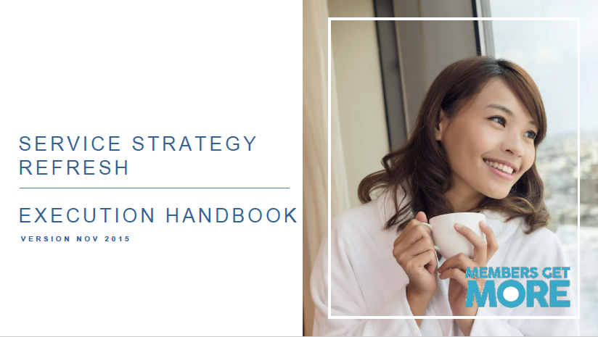

**万枫 – 中国地区 – 万豪礼赏服务策略SERVICE STRATEGY 2.0**

|  |  |  |  |  |  |  |  |  |
| --- | --- | --- | --- | --- | --- | --- | --- | --- |
| **会员礼遇一览表** | |  |  |  |  |  |  |  |
| No. | 服务提供 | Plat 5-Star | Plat Premier | Platinum | Gold | Silver | Basic | 特别备注 |
|  | OPERA PMS Coding | X5 | X4 | P6 | X1 | M1 | Y1 |  |
| 房型 | | | | | | | | |
| 1 | 房型保证 | Y | Y | Y | Y |  |  | 全球标准 |
| 2 | 床型保证 | Y | Y | Y |  |  |  | 全球标准 |
| 到店前 | | | | | | | | |
| 4A | 48小时预订保证 | Y | Y | Y |  |  |  | 全球标准 |
| 4B | 最终预订保证 | Y | Y | Y | Y | Y |  | 全球标准 |
| 办理入住 | | | | | | | | |
| 5B | MR会员优先登记通道 |  |  |  |  | Y | Y |  |
| 互联网 | | | | | | | | |
| 12A | 客房免费基础WIFI | Y | Y | Y | Y | Y | Y | 所有的新老会员，不区分预订渠道 |
| 12B | 免费 – 更高级别优质高速客房互联网接入 | Y | Y | Y | Y |  |  |  |
| 欢迎&送别礼遇 | | | | | | | | |
| 13 | 白金会员保证 – 到店礼品 | Y | Y | Y |  |  |  | 全球标准 |
| 14A | 客房欢迎礼遇与酒店总经理签名的欢迎卡 | Y | Y | Y |  |  |  | 每日补充 |
| 14B | 客房欢迎礼遇与行政委员会签名的欢迎卡 |  |  |  | Y | Y |  | 金卡和银卡会员: 仅入住当天 |

**会员礼遇细则**

|  |  |  |  |  |  |  |  |  |
| --- | --- | --- | --- | --- | --- | --- | --- | --- |
| No. | Service Deliverables | Plat 5-Star | Plat Premier | Platinum | Gold | Silver | Basic | Special Remarks |
|  | OPERA PMS Coding | X5 | X4 | P6 | X1 | M1 | Y1 |  |
| 1 | 房型保证 | Y | Y | Y | Y |  |  | 全球标准 |

* 白金会员比金卡会员优先
* 吸烟/非吸烟偏好也可根据住房情况给予优先考虑
* 枕头，房间位置，加床和婴儿床不保证
* 无履行保证赔偿：

$ 100 USD – JW, MH, RH, AK

* 1. $ 50 USD – CY
  2. $ 25 USD – FF
  3. 预订时必须包含忠诚度计划礼赏号码
  4. 赔偿支付和积分兑换的入住
  5. 当天的预订/酒店walk-in不符合获得赔偿的资格

|  |  |  |  |  |  |  |  |  |
| --- | --- | --- | --- | --- | --- | --- | --- | --- |
| No. | Service Deliverables | Plat 5-Star | Plat Premier | Platinum | Gold | Silver | Basic | Special Remarks |
|  | OPERA PMS Coding | X5 | X4 | P6 | X1 | M1 | Y1 |  |
| 2 | 床型保证 | Y | Y | Y |  |  |  | 全球标准 |

* 准确的床尺寸可能会有所不同
* 床型偏好必须包含在预订中
* 通过会议策划人员、旅行社、团队代理或其他第三方来源进行的预订必须包含这些信息以便包含在担保中

|  |  |  |  |  |  |  |  |  |
| --- | --- | --- | --- | --- | --- | --- | --- | --- |
| No. | Service Deliverables | Plat 5-Star | Plat Premier | Platinum | Gold | Silver | Basic | Special Remarks |
|  | OPERA PMS Coding | X5 | X4 | P6 | X1 | M1 | Y1 |  |
| 4A | 48小时预订保证 | Y | Y | Y |  |  |  | 全球标准 |

* + 白金会员可保证全球任何酒店的客房预订在抵达前48小时可预订
  + 仅适用于会员本人房间
  + 会员礼遇不能与下列情况同时使用:
  + 以促销或折扣价预订
  + 以积分兑换预订

|  |  |  |  |  |  |  |  |  |
| --- | --- | --- | --- | --- | --- | --- | --- | --- |
| No. | Service Deliverables | Plat 5-Star | Plat Premier | Platinum | Gold | Silver | Basic | Special Remarks |
|  | OPERA PMS Coding | X5 | X4 | P6 | X1 | M1 | Y1 |  |
| 4B | 最终预订保证 | Y | Y | Y | Y | Y |  | 全球标准 |

* + 无法兑现的酒店可能会将会员带到同类酒店，并支付当晚客房房费，同时，适用于以下补偿方案
  + 预订中必须包含忠诚度计划礼赏号码和有效的信用卡号码
  + 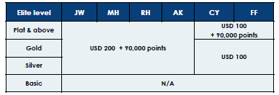对于亚太地区，白金及以上会员不允许更换酒店

以下示例脚本可用于通知客人酒店无法兑现预订：

Unfortunately, Mr./Ms. ____________, due to a few unexpected stay overs, we are overbooked. We have arranged alternate accommodations for you at the nearby ___________ hotel. We will be paying for room and tax for tonight as well as (one) long distance and (one) local phone call(s). Also, we will provide for your transportation to and from the hotel, if needed. We will inform anyone wishing to contact you of your new location. Is there anything else we should be aware of?

|  |  |  |  |  |  |  |  |  |
| --- | --- | --- | --- | --- | --- | --- | --- | --- |
| No. | Service Deliverables | Plat 5-Star | Plat Premier | Platinum | Gold | Silver | Basic | Special Remarks |
|  | OPERA PMS Coding | X5 | X4 | P6 | X1 | M1 | Y1 |  |
| 5B | MR会员优先登记通道 |  |  |  |  | Y | Y |  |

* + 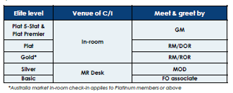房控负责到达前的规划信息和服务交付后续工作
  + RM / DOR带领金卡及以上会员入住客房并进行in-room入住登记手续
  + RM / DOR跟进咨询和请求并负责提供解决方案
  + 一个清晰可识别的柜台或指定的接待区，专门用于MR会员优先入住/退房
  + 我们最好的员工和主管人员在这个柜台上工作，这个柜台总是配有人员
  + 没有MR台卡？联系以下Property Support预订：

Guangzhou：chinaresourcedesk@marriott.com

Kuala Lumpur, Malaysia：klresourcedesk@marriott.com

Japan：tokyoresourcedesk@marriott.com



|  |  |  |  |  |  |  |  |  |
| --- | --- | --- | --- | --- | --- | --- | --- | --- |
| No. | Service Deliverables | Plat 5-Star | Plat Premier | Platinum | Gold | Silver | Basic | Special Remarks |
|  | OPERA PMS Coding | X5 | X4 | P6 | X1 | M1 | Y1 |  |
| 12A | 客房免费基础WIFI | Y | Y | Y | Y | Y | Y | MH Mulu 除外  所有新注册会员或会员，不区分预订渠道 |
| 12B | 免费 – 更高级别优质高速客房互联网接入 | Y | Y | Y | Y |  |  | MH Mulu除外 |

* 根据酒店网络品牌标准Property Internet Brand Standard, Dec 2014

|  |  |  |  |  |  |  |  |  |
| --- | --- | --- | --- | --- | --- | --- | --- | --- |
| No. | Service Deliverables | Plat 5-Star | Plat Premier | Platinum | Gold | Silver | Basic | Special Remarks |
|  | OPERA PMS Coding | X5 | X4 | P6 | X1 | M1 | Y1 |  |
| 13 | 白金会员保证 – 到店礼品 | Y | Y | Y |  |  |  | 全球标准 |

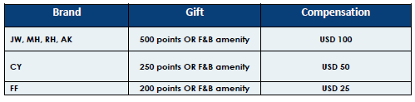

* 酒店可以参考[MGS的选择清单](https://extranet.marriott.com/mgs/marrdocs/mgs/common/lodgingoperations/rooms/frontofficeadmin/procedures/prearrival/giftselection.pdf)，或选择当地设施，让白金会员真正感觉受到欢迎
* 累积里程的会员仅可选择酒店内餐饮服务，因为奖励里程不可作为该会员礼遇的一部分

|  |  |  |  |  |  |  |  |  |
| --- | --- | --- | --- | --- | --- | --- | --- | --- |
| No. | Service Deliverables | Plat 5-Star | Plat Premier | Platinum | Gold | Silver | Basic | Special Remarks |
|  | OPERA PMS Coding | X5 | X4 | P6 | X1 | M1 | Y1 |  |
| 14A | 客房欢迎礼遇与酒店总经理签名的欢迎卡 | Y | Y | Y |  |  |  | 每日补充 |
| 14B | 客房欢迎礼遇与行政委员会签名的欢迎卡 |  |  |  | Y | Y |  | 金卡和银卡会员: 仅入住当天 |

* 在客房内放置
* 精英会员的欢迎服务，由酒店团队决定，旨在为会员创造出一种宾至如归的感觉



14A – 手写并签名的欢迎卡样品 14B – 签名欢迎卡样品

**如有需要**

**重温Service Strategy培训**

**请联系您的区域运营总监或Property Support团队：**

1. Japan: tokyoresourcedesk@marriott.com
2. Greater China: chinaresourcedesk@marriott.com
3. Rest of Asia Pacific: klresourcedesk@marriott.com